21/11/2024

DSA PRACTICE DAY 9

**1.VALID PALINDROME:**

**Code:**

public class Solution {

public boolean isPalindrome(String s) {

int l = 0;

int r = s.length() - 1;

while (l < r) {

if (!Character.isLetterOrDigit(s.charAt(l))) {

l++;

} else if (!Character.isLetterOrDigit(s.charAt(r))) {

r--;

}

else if (Character.toLowerCase(s.charAt(l)) == Character.toLowerCase(s.charAt(r))) {

l++;

r--;

} else {

return false;

}

}

return true;

}

public static void main(String[] args) {

Solution solution = new Solution();

String s = "A man, a plan, a canal: Panama";

System.out.println("Is palindrome: " + solution.isPalindrome(s));

}

}

**OUTPUT:**

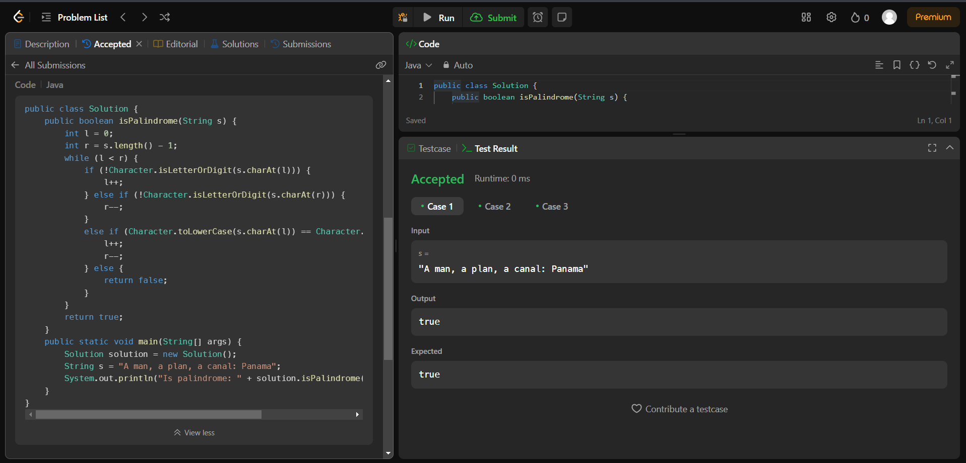

**2.IS SUBSEQUENCE:**

**Code:**

public class Solution {

public boolean isSubsequence(String s, String t) {

int i = 0, j = 0;

while (i < s.length() && j < t.length()) {

if (s.charAt(i) == t.charAt(j)) {

i++;

}

j++;

}

return i == s.length();

}

public static void main(String[] args) {

Solution solution = new Solution();

String s = "abc";

String t = "ahbgdc";

System.out.println("Is subsequence: " + solution.isSubsequence(s, t));

}

}

**OUTPUT:**

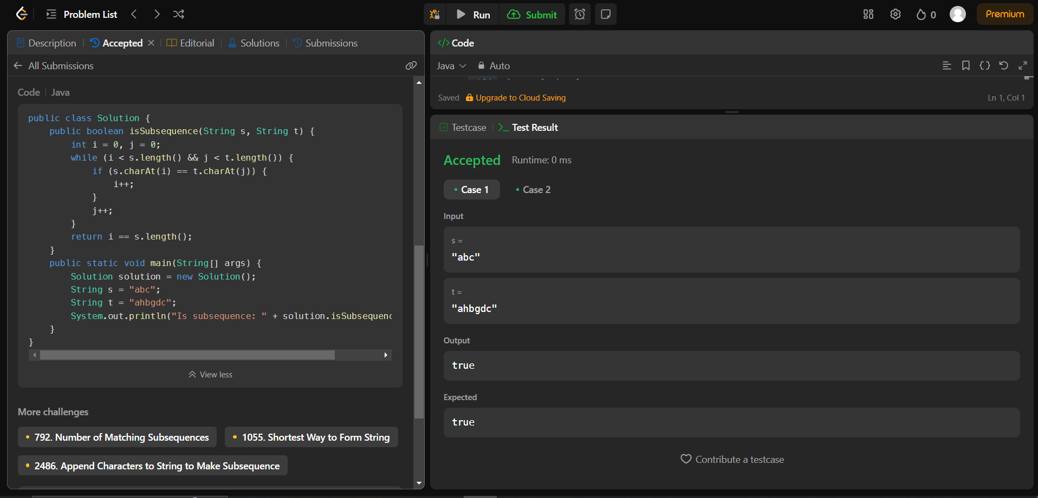

**3.TWO SUM II -INPUT ARRAY IS SORTED**

**CODE:**

class Solution {

public int[] twoSum(int[] numbers, int target) {

int left = 0;

int right = numbers.length - 1;

while (left < right) {

int total = numbers[left] + numbers[right];

if (total == target) {

return new int[]{left + 1, right + 1};

} else if (total > target) {

right--;

} else {

left++;

}

}

return new int[]{-1, -1};

}

}

**OUTPUT:**

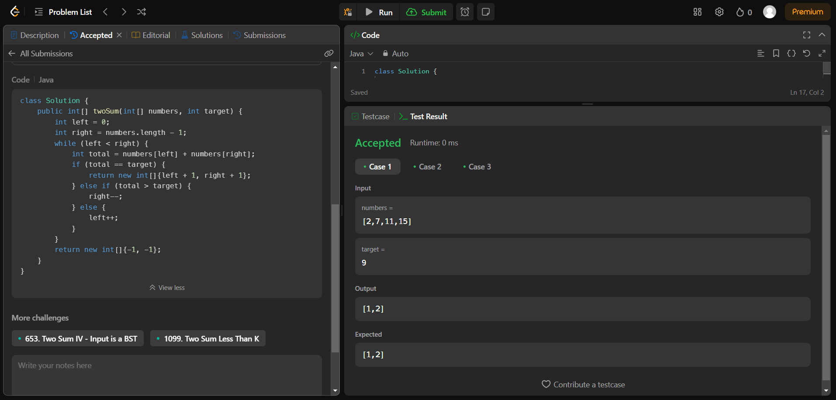

**4.CONTAINER WITH MOST WATER:**

**CODE:**

class Solution {

public int maxArea(int[] height) {

int maxArea = 0;

int left = 0;

int right = height.length - 1;

while (left < right) {

maxArea = Math.max(maxArea, (right - left) * Math.min(height[left], height[right]));

if (height[left] < height[right]) {

left++;

} else {

right--;

}

}

return maxArea;

}

}

**OUTPUT:**

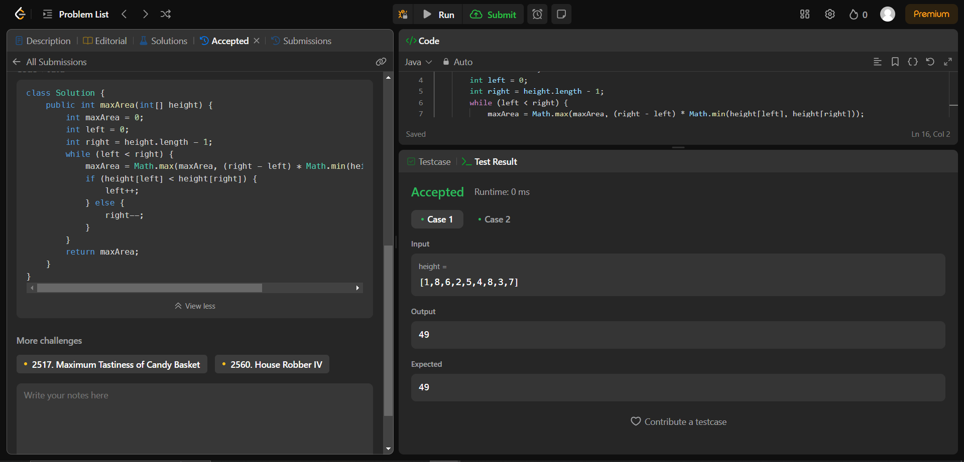

**5.3SUM:**

**CODE:**

import java.util.*;

class Solution {

public List<List<Integer>> threeSum(int[] nums) {

Arrays.sort(nums);

List<List<Integer>> l = new ArrayList<>();

for (int i = 0; i < nums.length - 2; i++) {

if (i > 0 && nums[i] == nums[i - 1]) continue;

int res = 0 - nums[i];

int start = i + 1;

int end = nums.length - 1;

while (start < end) {

int sum = nums[start] + nums[end];

if (sum == res) {

l.add(Arrays.asList(nums[i], nums[start], nums[end]));

while (start < end && nums[start] == nums[start + 1]) start++;

while (start < end && nums[end] == nums[end - 1]) end--;

start++;

end--;

} else if (sum > res) {

end--;

} else {

start++;

}

}

}

return l;

}

}

**OUTPUT:**

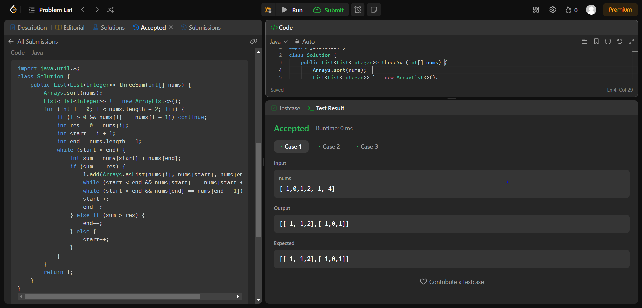

**6.MINIMUM SIZE SUBARRAY SUM:**

**CODE:**

class Solution {

public int minSubArrayLen(int target, int[] nums) {

int minLen = Integer.MAX_VALUE;

int left = 0;

int curSum = 0;

for (int right = 0; right < nums.length; right++) {

curSum += nums[right];

while (curSum >= target) {

if (right - left + 1 < minLen) {

minLen = right - left + 1;

}

curSum -= nums[left];

left++;

}

}

return minLen != Integer.MAX_VALUE ? minLen : 0;

}

}

**OUTPUT:**

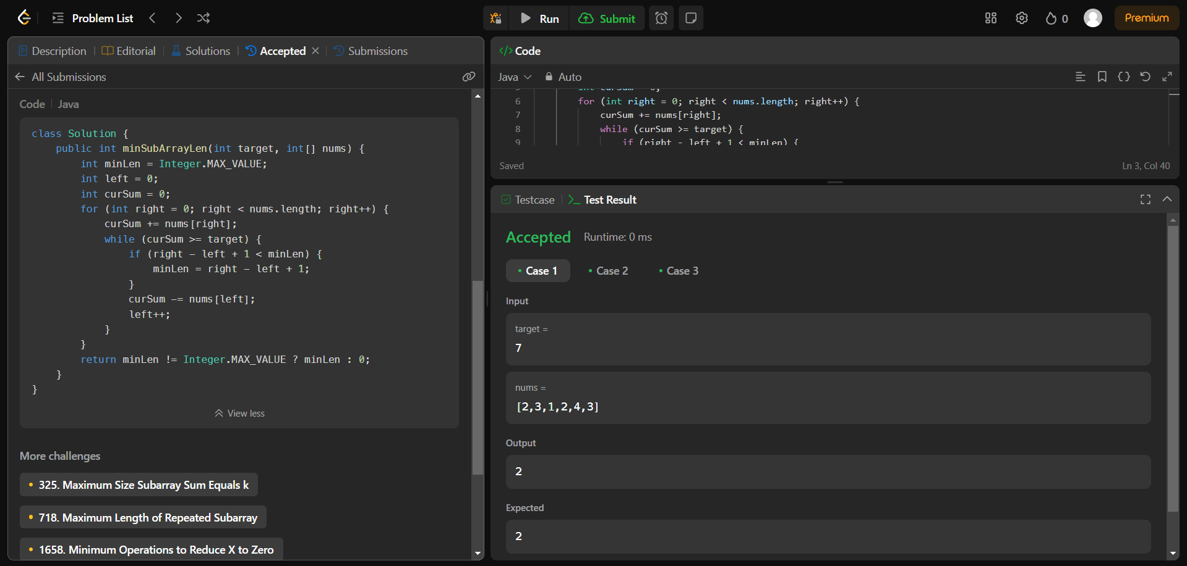

**7.LONGEST SUBSTRING WITHOUT REPEATING CHARACTERS:**

**CODE:**

class Solution {

public int lengthOfLongestSubstring(String s) {

int left = 0;

int maxLength = 0;

HashSet<Character> charSet = new HashSet<>();

for (int right = 0; right < s.length(); right++) {

while (charSet.contains(s.charAt(right))) {

charSet.remove(s.charAt(left));

left++;

}

charSet.add(s.charAt(right));

maxLength = Math.max(maxLength, right - left + 1);

}

return maxLength;

}

}

**OUTPUT:**

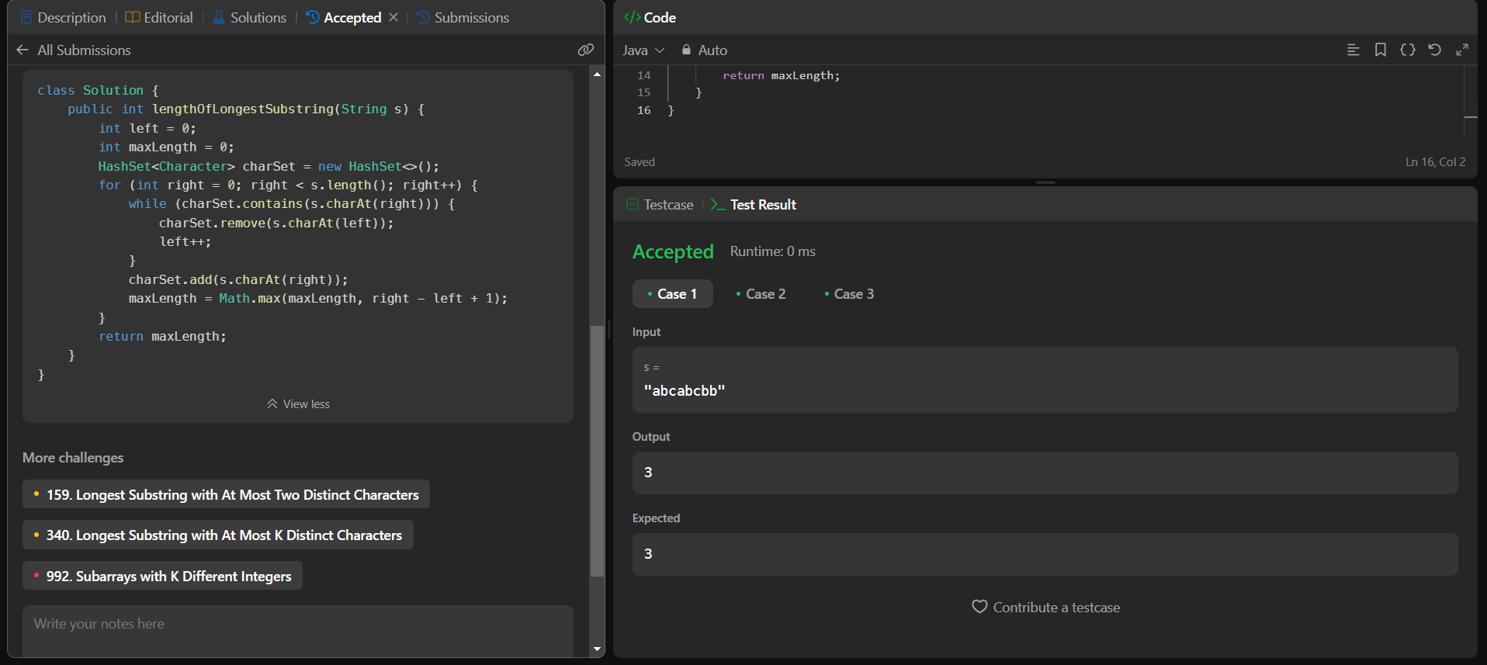

**8.SUBSTRING WITH CONCATENATION OF ALL WORDS:**

**CODE:**

class Solution {

public List<Integer> findSubstring(String s, String[] words) {

final Map<String, Integer> counts = new HashMap<>();

for (final String word : words) {

counts.put(word, counts.getOrDefault(word, 0) + 1);

}

final List<Integer> indexes = new ArrayList<>();

final int n = s.length(), num = words.length, len = words[0].length();

for (int i = 0; i < n - num * len + 1; i++) {

final Map<String, Integer> seen = new HashMap<>();

int j = 0;

while (j < num) {

final String word = s.substring(i + j * len, i + (j + 1) * len);

if (counts.containsKey(word)) {

seen.put(word, seen.getOrDefault(word, 0) + 1);

if (seen.get(word) > counts.getOrDefault(word, 0)) {

break;

}

} else {

break;

}

j++;

}

if (j == num) {

indexes.add(i);

}

}

return indexes;

}

}

**OUTPUT:**



**9.MINIMUM WINDOW SUBSTRING:**

**CODE:**

class Solution {

public String minWindow(String s, String t) {

if (s.length() < t.length()) {

return "";

}

Map<Character, Integer> charCount = new HashMap<>();

for (char ch : t.toCharArray()) {

charCount.put(ch, charCount.getOrDefault(ch, 0) + 1);

}

int targetCharsRemaining = t.length();

int[] minWindow = {0, Integer.MAX_VALUE};

int startIndex = 0;

for (int endIndex = 0; endIndex < s.length(); endIndex++) {

char ch = s.charAt(endIndex);

if (charCount.containsKey(ch) && charCount.get(ch) > 0) {

targetCharsRemaining--;

}

charCount.put(ch, charCount.getOrDefault(ch, 0) - 1);

if (targetCharsRemaining == 0) {

while (true) {

char charAtStart = s.charAt(startIndex);

if (charCount.containsKey(charAtStart) && charCount.get(charAtStart) == 0) {

break;

}

charCount.put(charAtStart, charCount.getOrDefault(charAtStart, 0) + 1);

startIndex++;

}

if (endIndex - startIndex < minWindow[1] - minWindow[0]) {

minWindow[0] = startIndex;

minWindow[1] = endIndex;

}

charCount.put(s.charAt(startIndex), charCount.getOrDefault(s.charAt(startIndex), 0) + 1);

targetCharsRemaining++;

startIndex++;

}

}

return minWindow[1] >= s.length() ? "" : s.substring(minWindow[0], minWindow[1] + 1);

}

}

**OUTPUT:**

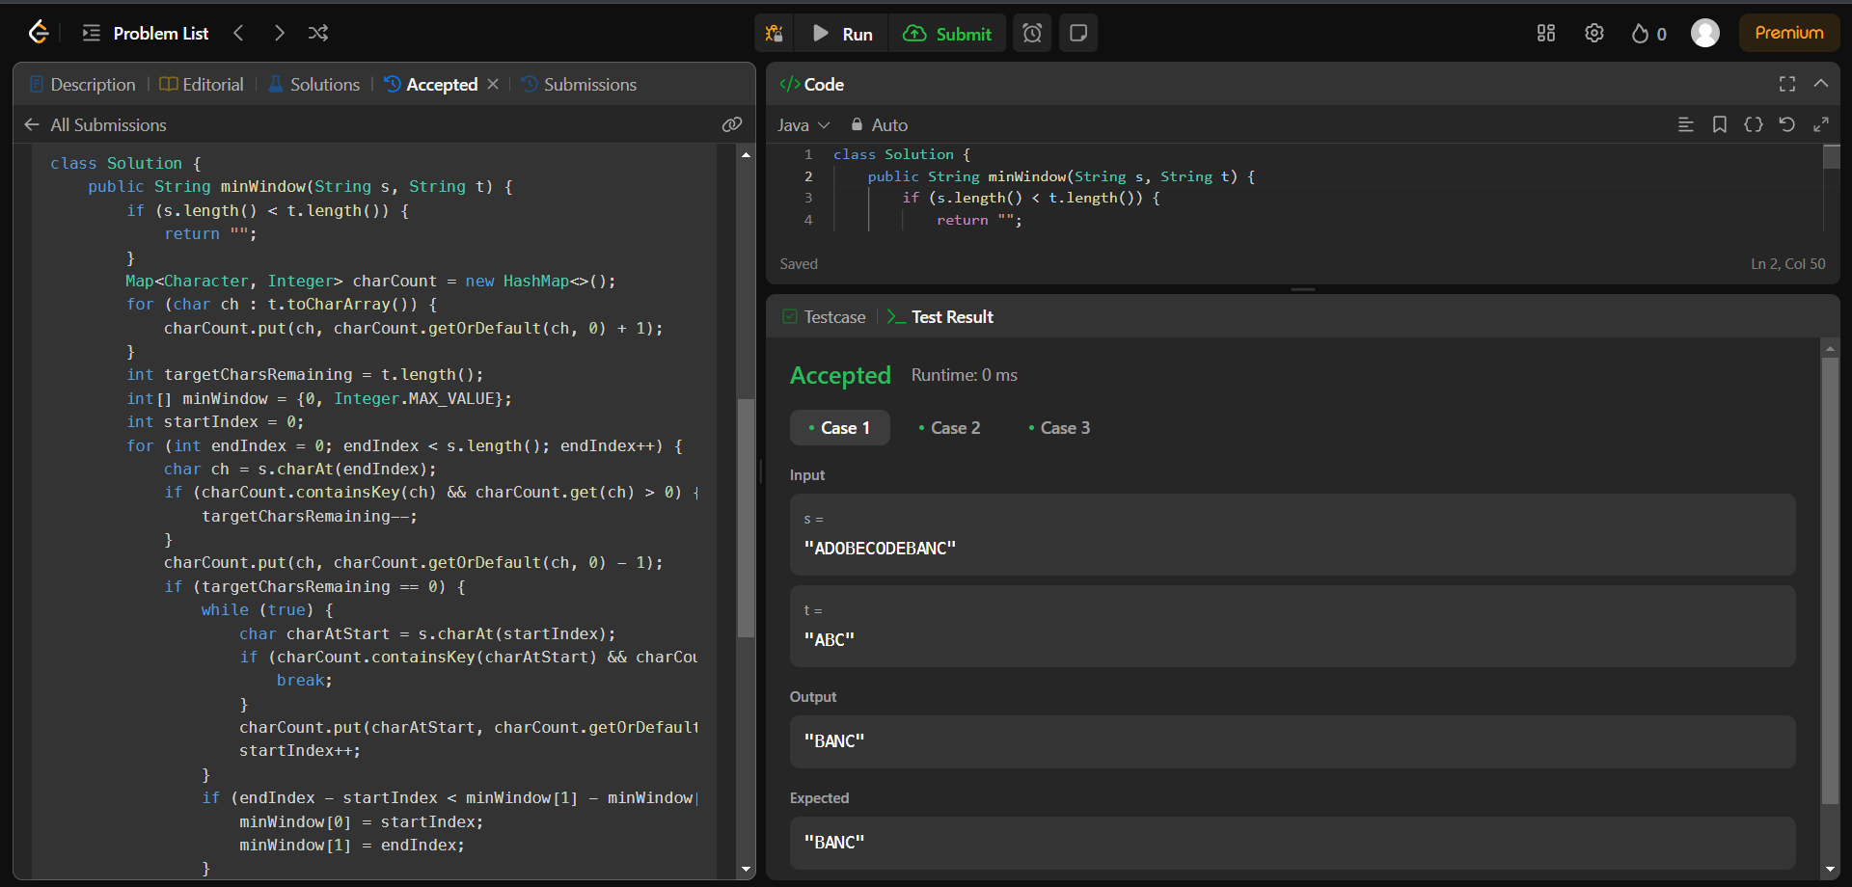

**10.VALID PARENTHESES:**

**CODE:**

class Solution {

public boolean isValid(String s) {

Stack<Character> stack = new Stack<>();

Map<Character, Character> mapping = new HashMap<>();

mapping.put(')', '(');

mapping.put('}', '{');

mapping.put(']', '[');

for (char c : s.toCharArray()) {

if (mapping.containsValue(c)) {

stack.push(c);

} else if (mapping.containsKey(c)) {

if (stack.isEmpty() || mapping.get(c) != stack.pop()) {

return false;

}

}

}

return stack.isEmpty();

}

}

**OUTPUT:**

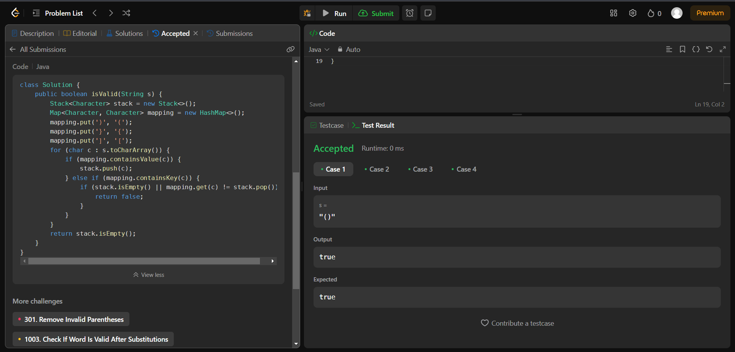

**11.SIMPLIFY PATH:**

**CODE:**

class Solution {

public String simplifyPath(String path) {

Stack<String> stack = new Stack<>();

String[] directories = path.split("/");

for (String dir : directories) {

if (dir.equals(".") || dir.isEmpty()) {

continue;

} else if (dir.equals("..")) {

if (!stack.isEmpty()) {

stack.pop();

}

} else {

stack.push(dir);

}

}

return "/" + String.join("/", stack);

}

}

**OUTPUT:**

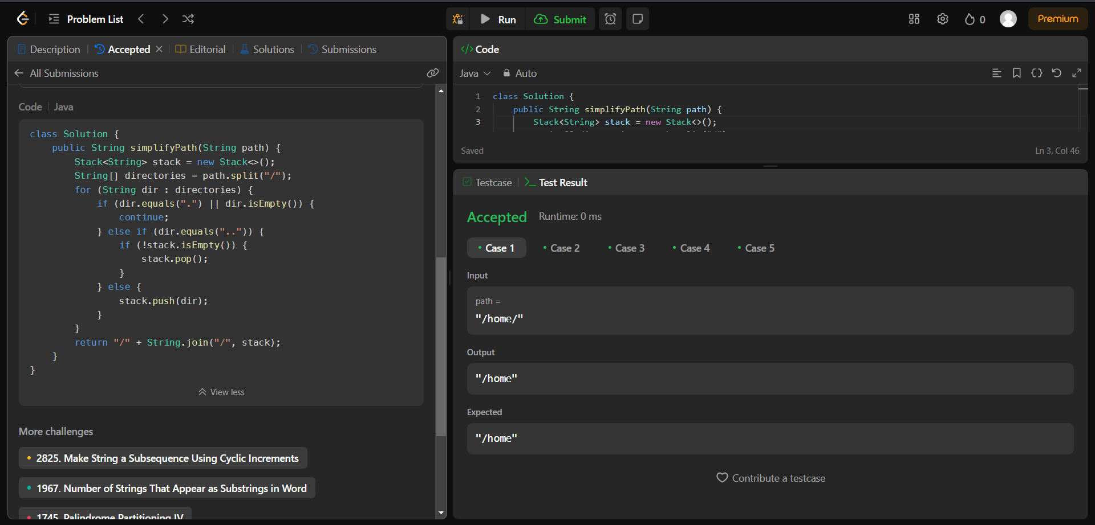

**12.MIN STACK:**

**CODE:**

class MinStack {

private List<int[]> st;

public MinStack() {

st = new ArrayList<>();

}

public void push(int val) {

int[] top = st.isEmpty() ? new int[]{val, val} : st.get(st.size() - 1);

int min_val = top[1];

if (min_val > val) {

min_val = val;

}

st.add(new int[]{val, min_val});

}

public void pop() {

st.remove(st.size() - 1);

}

public int top() {

return st.isEmpty() ? -1 : st.get(st.size() - 1)[0];

}

public int getMin() {

return st.isEmpty() ? -1 : st.get(st.size() - 1)[1];

}

}

**OUTPUT:**

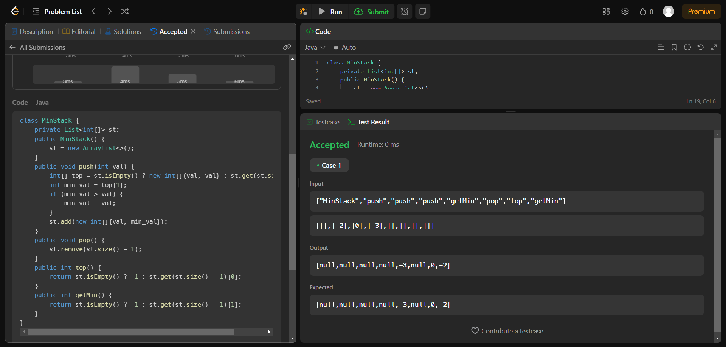

**13.EVALUATE REVERSE POLISH NOTATION:**

**CODE:**

class Solution {

public int evalRPN(String[] tokens) {

Stack<Integer> stack = new Stack<>();

for (String c : tokens) {

if (c.equals("+")) {

stack.push(stack.pop() + stack.pop());

} else if (c.equals("-")) {

int second = stack.pop();

int first = stack.pop();

stack.push(first - second);

} else if (c.equals("*")) {

stack.push(stack.pop() * stack.pop());

} else if (c.equals("/")) {

int second = stack.pop();

int first = stack.pop();

stack.push(first / second);

} else {

stack.push(Integer.parseInt(c));

}

}

return stack.peek();

}

}

**OUTPUT:**

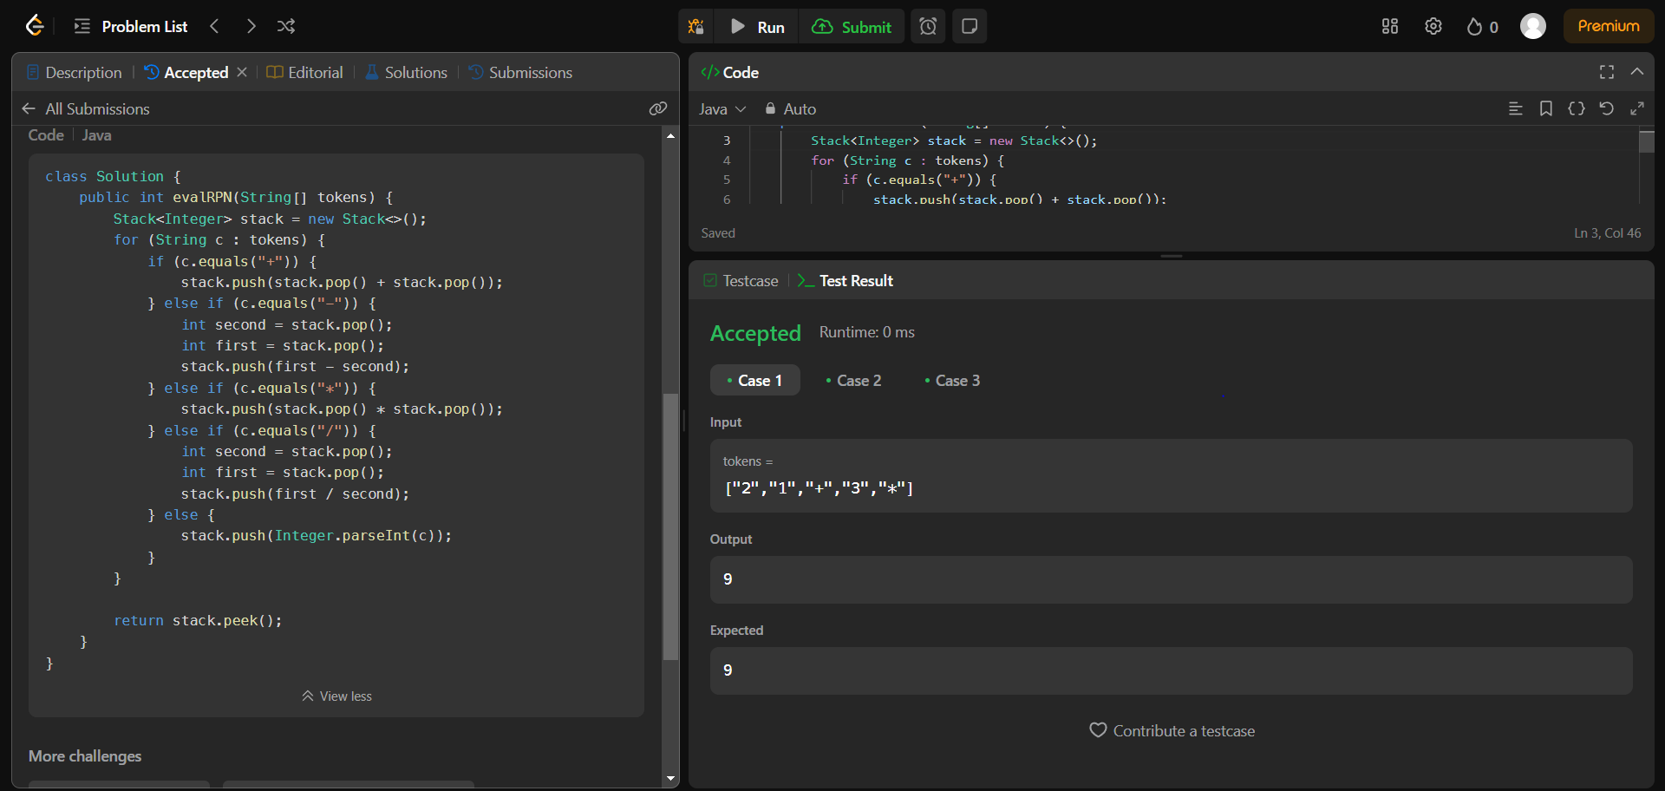

**14.BASIC CALCULATOR:**

**CODE:**

class Solution {

public int calculate(String s) {

int number = 0;

int signValue = 1;

int result = 0;

Stack<Integer> operationsStack = new Stack<>();

for (int i = 0; i < s.length(); i++) {

char c = s.charAt(i);

if (Character.isDigit(c)) {

number = number * 10 + (c - '0');

} else if (c == '+' || c == '-') {

result += number * signValue;

signValue = (c == '-') ? -1 : 1;

number = 0;

} else if (c == '(') {

operationsStack.push(result);

operationsStack.push(signValue);

result = 0;

signValue = 1;

} else if (c == ')') {

result += signValue * number;

result *= operationsStack.pop();

result += operationsStack.pop();

number = 0;

}

}

return result + number * signValue;

}

}

**OUTPUT:**

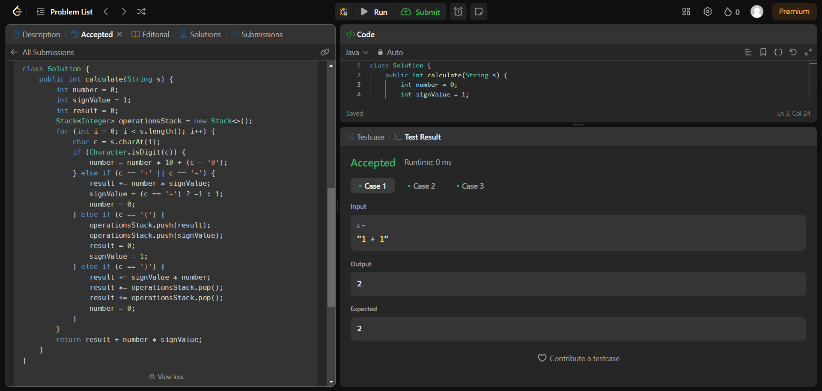

**15.SEARCH INSERT POSITION:**

**CODE:**

class Solution {

public int searchInsert(int[] nums, int target) {

int left = 0;

int right = nums.length - 1;

while (left <= right) {

int mid = left + (right - left) / 2;

if (nums[mid] == target) {

return mid;

} else if (nums[mid] > target) {

right = mid - 1;

} else {

left = mid + 1;

}

}

return left;

}

}

**OUTPUT:**

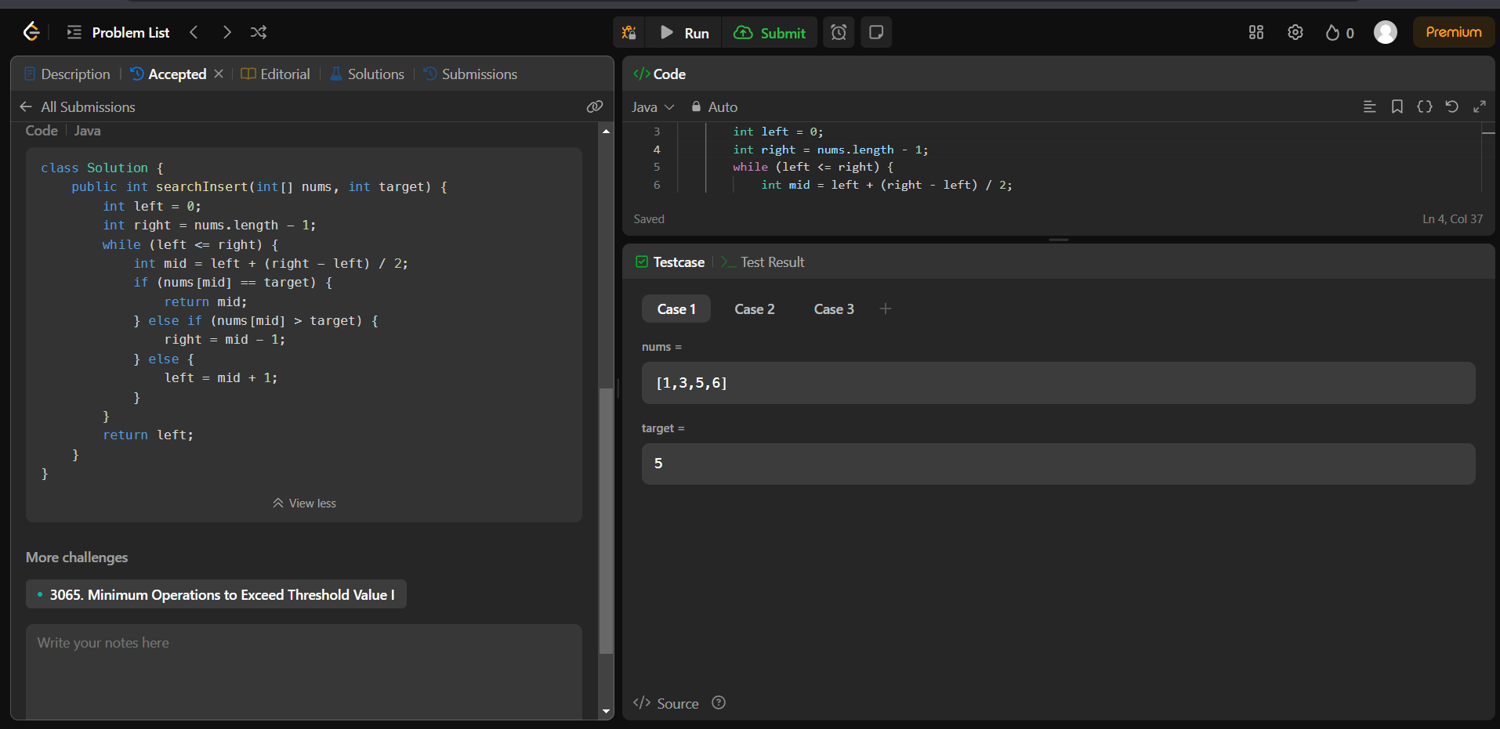

**16.SEARCH A 2D MATRIX:**

**CODE:**

class Solution {

public boolean searchMatrix(int[][] matrix, int target) {

int m = matrix.length;

int n = matrix[0].length;

int i=0;

int j=n-1;

while(i<m && j>=0){

if(matrix[i][j]==target) return true;

if(matrix[i][j]>target){

j--;

}

else{

i++;

}

}

return false;

}

}

**OUTPUT:**

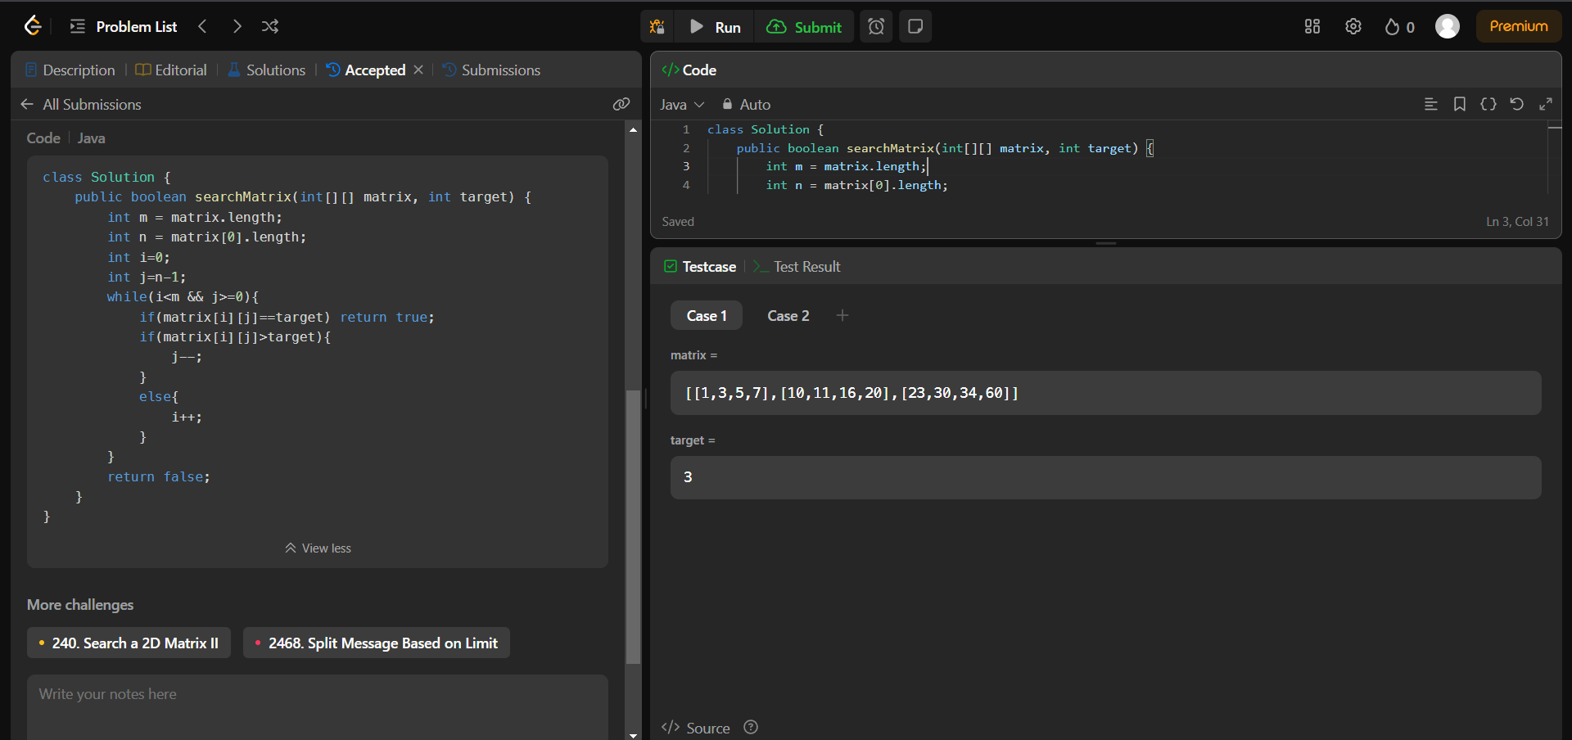

**17.FIND PEAK ELEMENT:**

**CODE:**

class Solution {

public int findPeakElement(int[] nums) {

int left = 0;

int right = nums.length - 1;

while (left < right) {

int mid = (left + right) / 2;

if (nums[mid] > nums[mid + 1]) {

right = mid;

} else {

left = mid + 1;

}

}

return left;

}

}

**OUTPUT:**

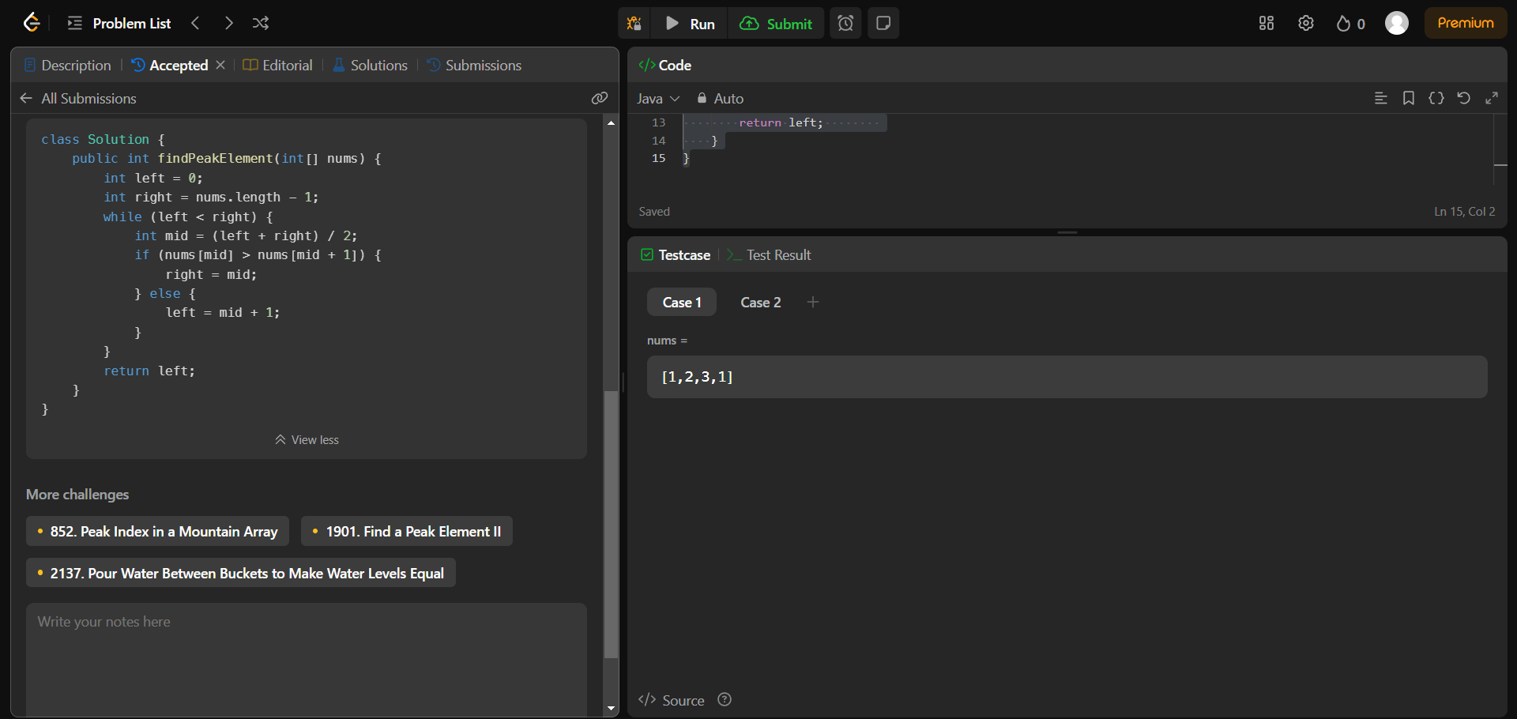

**18.SEARCH IN ROTATED SORTED ARRAY:**

**CODE:**

class Solution{

public int search(int[]nums,int target){

int left=0,right=nums.length-1;

while(left<=right){

int mid=left+(right-left)/2;

if(nums[mid]==target)return mid;

if(nums[left]<=nums[mid]){

if(nums[left]<=target&&target<nums[mid]){

right=mid-1;

}else{

left=mid+1;

}

}else{

if(nums[mid]<target&&target<=nums[right]){

left=mid+1;

}else{

right=mid-1;

}

}

}

return-1;

}

}

**OUTPUT:**

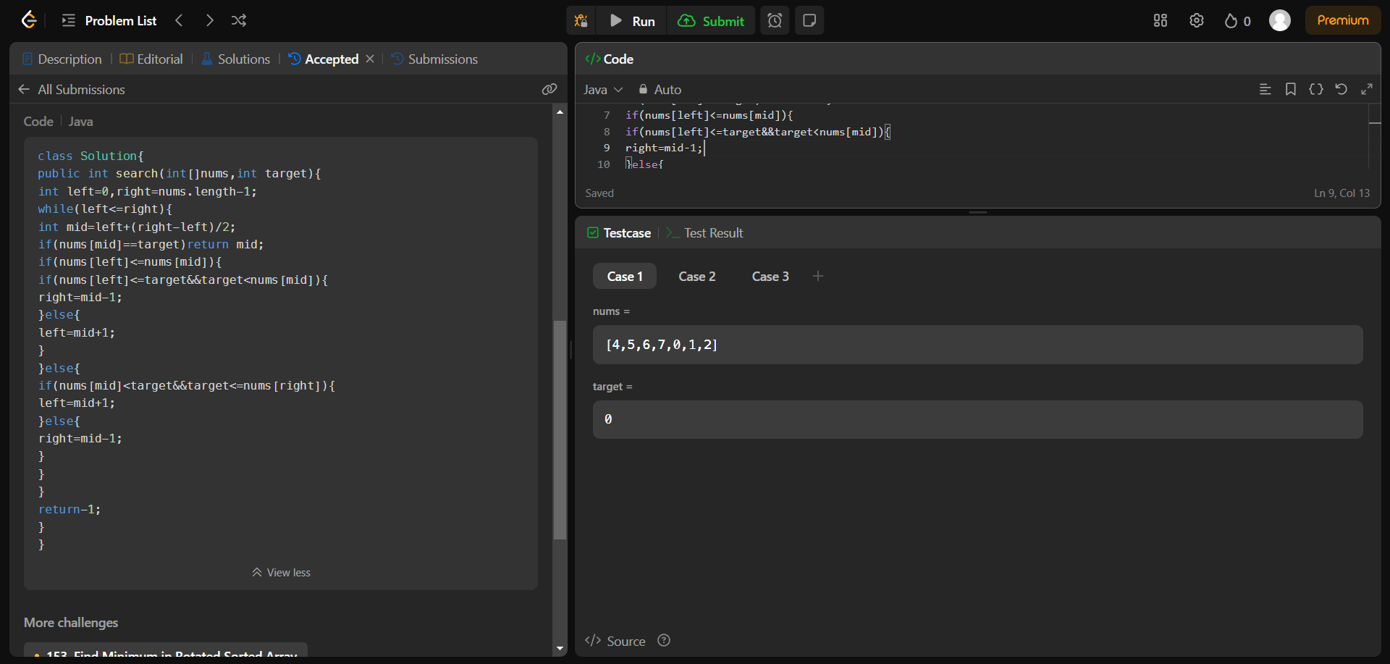

**19.FIND FIRST AND LAST POSITION OF ELEMENT SORTED IN ARRAY:**

**CODE:**

class Solution {

public int[] searchRange(int[] nums, int target) {

int[] result = {-1, -1};

int left = binarySearch(nums, target, true);

int right = binarySearch(nums, target, false);

result[0] = left;

result[1] = right;

return result;

}

private int binarySearch(int[] nums, int target, boolean isSearchingLeft) {

int left = 0;

int right = nums.length - 1;

int idx = -1;

while (left <= right) {

int mid = left + (right - left) / 2;

if (nums[mid] > target) {

right = mid - 1;

} else if (nums[mid] < target) {

left = mid + 1;

} else {

idx = mid;

if (isSearchingLeft) {

right = mid - 1;

} else {

left = mid + 1;

}

}

}

return idx;

}

}

**OUTPUT:**

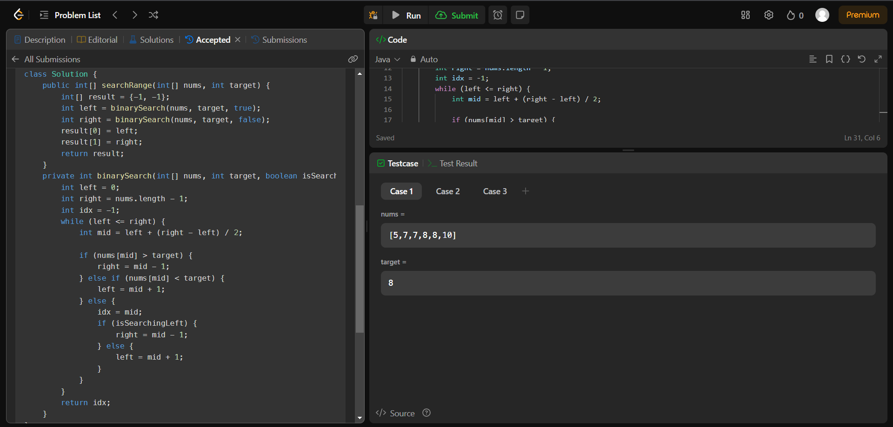

**20.FIND MINIMUM IN ROTATED SORTED ARRAY:**

**CODE:**

class Solution {

public int findMin(int[] nums) {

int left = 0;

int right = nums.length - 1;

while (left < right) {

int mid = left + (right - left) / 2;

if (nums[mid] <= nums[right]) {

right = mid;

} else {

left = mid + 1;

}

}

return nums[left];

}

}

**OUTPUT:**

